WDD 330 Final Web Application Proposal

Chow Hall

Overview
The Chow Hall Application is a web platform designed to help users plan meals for a given number of people. The platform addresses the common challenges of finding recipes, planning meals, managing pantry inventory, and generating shopping lists. Using the MealDB.com API, this project will empower hosts to create meal plans, track inventory, and create a shopping list for the meal plan.

Target Audience
Putting in the required calorie intake for a meal as well as ensuring you are not short on ingredients can be a challenge for preparing a group meal. The purpose of this application is to facilitate meal planning while helping users track ingredients that are currently in stock and identify ingredients that need to be purchased. The mobile view will assist with the shopping list as the user is getting their supplies.

Primary Users:
Hosts of small to medium gatherings such as dinners at home, reunions, or small public gatherings.

Secondary Users:
Individuals seeking to maintain an inventory of food and pantry items.

Major Functions
• Meal Search and Compilation of Meal Plan:
Enable users to search for recipes using the MealDB.com API.
• Meal Plan Generator:
Generate a complete meal plan (appetizer, main course, and dessert) and allow users to customize the generated selections.
• Ingredient Shopping List:
Automatically create a shopping list based on selected recipes, with the quantities reduced to how much is not already in the pantry.
• Save and Share Meal Plans:
Users can save meal plans for future use and import or export plans for sharing and backup purposes.
• Responsive Design:
Provide a seamless experience across mobile and desktop with intuitive navigation and clean layouts. Allow users to access and update shopping lists while shopping from a mobile device.
• CSS Animations:
Include animations for page transitions, loading indicators, processing indicators, and interactive elements (e.g., hover effects on buttons).
• Recipe home country lookup:
Satisfy that itch of curiosity to find out more about here the recipe comes from.
• Word definition lookup:
Allow the users to get definitions of words, either of ingredients or words in the instructions.

Wireframes

Laptop
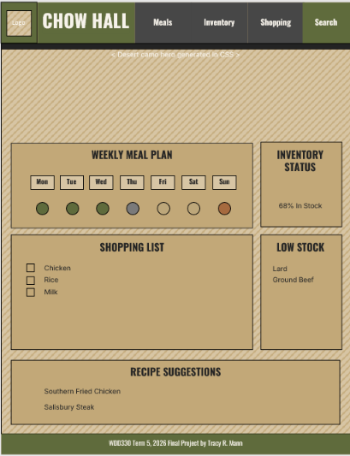

Mobile
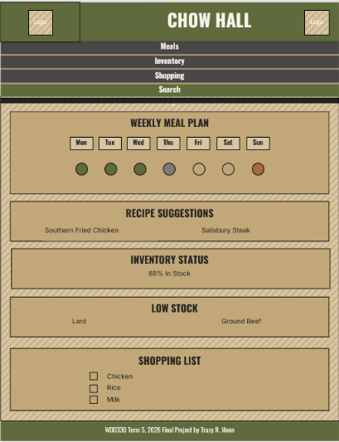

External Data
• MealDB.com API: Data used: Recipe details (name, image, instructions, country), and ingredient lists.
• RestCountries.com API: Data used: Country details such as name, capital, flag image, region, subregion, land area, currencies, languages, leadership, group memberships
• DictionaryAPI.com API: Data used: Information on words such as part of speech to determine if a lookup link will be made available and the definition of the word when it is available.

Data Storage
• Saved meal plans, pantry inventory, and shopping lists will be stored using Local Storage. These will also be available to be downloaded or uploaded to be saved or opened from the users local filesystem storage.
• Cached API called to reduce hits against the API and speed of page response will also be stored using Local Storage.

Module List
• Home Page Module:
Displays the app's purpose and entry points to features.
• Search Module:
Interfaces with the MealDB.com API to fetch and display recipes.
• Meal Plan Module:
Combines selected recipes into a coherent meal plan.
• Pantry Inventory Module:
Tracks ingredients currently available in the user's pantry and maintains quantity information.
• Shopping List Module:
Converts meal plan ingredients into an organized shopping list with quantity reduced by stock on hand.
• Responsive Layout Module:
Ensures the UI adapts to various screen sizes
• Word Details Module:
Ensures the UI adapts to various screen sizes
• Country Details Module:
Ensures the UI adapts to various screen sizes

Graphic Identity

Colors:
Color Wheel
Dust Storm
#D7C5A4
 | Ranger Green  #4B5D42 |  | Khaki Field  #BDA77A
Desert Sand
#C2A878
 | Tactical Olive  #5F6B3C |  | Copper Canteen  #A66A3F
Expedition Brown
#7B5A3A

• Primary:
Main | Desert Sand | #C2A878 | (194,168,120)
Headers, Navigation, and Controls | Tactical Olive | #5F6B3C | (95, 107, 60)
Emphasis and accents | Expedition Brown | #7B5A3A | (123, 90, 58)

• Secondary:
 | Ranger Green | #4B5D42
 | Dust Storm | #D7C5A4
 | Khaki Field | #BDA77A
 | Copper Canteen | #A66A3F

• Neutral:
 | Command Black | #232323
 | Charcoal | #474747
 | Supply Gray | #7A7A7A
 | Field Stone | #B8B2A8
 | Off White

Typography
• Heading: "Oswald" (Sans-serif)
https://fonts.google.com/specimen/Oswald
• Body: "Inter" (Sans-serif)
https://fonts.google.com/specimen/Inter

Icon Design
• A chow hall Tray.

Timeline (Weeks 5-7)

Week 5
• Finalized wireframes and graphic identity.
• Implement the homepage with basic CSS animations.
• Implement responsive layouts for search results, meal plans, pantry inventory and shopping list.

Week 6
• Establish API connections and fetch sample data.
• Develop the word details and country details module.
• Develop the pantry inventory and shopping list module.
• Develop search and meal plan modules.

Week 7
• Complete the shopping list module.
• Debug and refine animations.
• Perform final testing and accessibility checks.

Project Planning
A detailed Trello board will include the following tasks:
• Create wireframes and finalize UI design.
• Set up API connection.
• Develop individual modules (home page, search, meal plan).
• Test responsiveness and animations.
• Perform usability testing and polish UI.
https://trello.com/invite/b/6ac09d6cd6f2f9768f8c6302/ATTI7540b727cfcbaac40a8c9f46afea53c22C6E51A2/wdd330-term-5-final-project-chow-hall-by-tracy-mann

Challenges
The main concerns I have on this project:
• Ensuring the API rate limits are managed based on free access.
• Completion of the entire project in the limited time remaining.
• Develop individual modules (home page, search, meal plan).
• Test responsiveness and animations.

